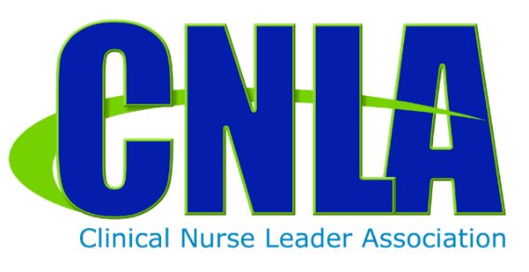

**2018 CNLA Fall Conference and CNL Certification Exam Review Course**

**Event Vendor Information**

**Cost: $111 per booth; nonrefundable**  
**The 2018 CNLA Fall Conference and CNL Certification Exam Review Course will be held in Charlotte, North Carolina, the "Queen City," on the beautiful campus of Queen's University of Charlotte, at the Sports Complex & Conference Center.**

Information needed at time of registration:

COMPANY: ____________________________________________________________

CONTACT PERSON: _____________________________________________________

ADDRESS: _____________________________________________________________

PHONE: ________________________________________________________________

EMAIL: ________________________________________________________________

Description of promotion: _________________________________________________

Neither CNLA nor their affiliates will be held responsible for any liability, lost or stolen or damaged merchandise or any injury incurred during conference.

**Links for payment and registration at** [**www.cnlassociation.org**](http://www.cnlassociation.org)