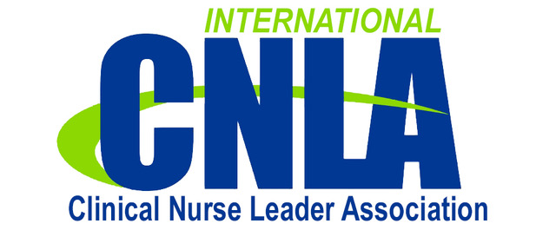
CALL FOR ABSTRACTS

Clinical Nurse Leader Association Fall Conference 2018
September 17-18, 2018
Queens, University of Charlotte Sports Complex
Charlotte, North Carolina

Abstract Guidelines
Abstracts may be submitted for poster or podium presentation
Abstracts must be submitted by email attachment
Abstracts should reflect CNL practice/outcomes
Abstracts must be submitted with attached 2018 CNLA Fall Conference submission form
Abstracts received after June 1st will not be considered
Send all abstracts/questions via email to: Annette Hines: hinesa@queens.edu
Review and selection: The 2018 Planning Committee will make final selections; submitters will be notified of acceptance by June 15th, 2018

2018 CNLA Fall Conference Abstract Submission Form

Title of Presentation: _______________________________________________

Primary Author: ___________________________________________________
Additional Author(s) ________________________________________________
Organizational Affiliation: ___________________________________________
Email Address: ____________________________________________________
Contact Phone Number: ____________________________________________

Format requested:
____ Podium Presentation ____ Poster Presentation _____ Either

Please submit abstract on a separate document utilizing the following guidelines:
- Submit as a Microsoft WORD document, with font size 12 Times New Roman, and 1 inch margins
- Maximum of 500 words (not counting headings)
- Author names and identifiers are to be excluded, so a blinded review is possible
- File name should not include identifiers or author names
- Include the following categories, using clearly identified headings (as applicable)
  - Title (Must match the title on this form EXACTLY)
  - Purpose/Objective
  - Significance
  - Design/Methods
  - Findings/Outcomes
  - Conclusion/Implications for Practice

