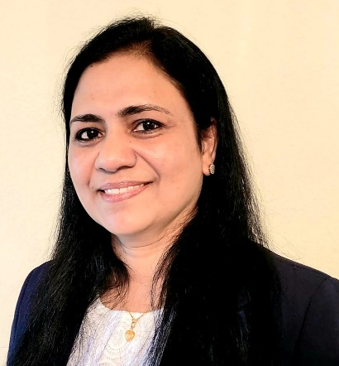

May 2021

The Academy of Medical-Surgical Nurses (AMSN) has awarded its 2021 Clinical Practice Award to CNLA member, Ms. Jessy Cherukunnathu, MSN, RN, CNL, CMSRN. Ms. Cherukunnathu is a Clinical Nurse Leader within the North Texas VA Healthcare System. Her work in improving outcomes for the Veteran population exemplifies the attributes that define high quality nursing care. Ms. Cherukunnathu acknowledges the exceptional work and the collaborative relationships of her fellow Dallas VA Medical Center’s nurses, nursing assistants, and nursing leadership when receiving this award.

The AMSN has awarded Ms. Cherukunnathu with complimentary registration to the AMSN convention and an honorarium. The AMSN will present the award during its 30th annual convention in September 2021.

Great work Jessy!